**Website Testing Plan Template**

**Evidence**

*Include evidence that tests have been undertaken.*

*This can be screenshots, error or bugs strings, reports or any further evidence of testing. Include any documentation in the test folder but they must be named appropriately and referenced in the test plan or clearly written down.*

*Further testing evidence can be included under the testing heading if required.*

**Testing plan**

*Use the following template to guide your testing. You may add to the template so that it relates specifically to your website and testing requirements. An example for each section has been given as a guide to how to complete the table only.*

**Functional testing**

|  |  |  |  |  |
| --- | --- | --- | --- | --- |
| **Test** | **Expected Result** | **Actual Result** | **Comments** | **Reference to evidence** |
| *1.Product image zoom* | *When clicked image will zoom* | *Passed* |  | *Listed below.* |
|  |  |  |  |  |

**Functional testing evidence:**

*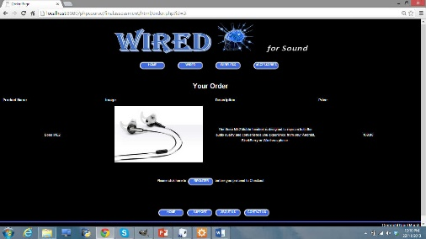Test1. Product image zoom*

**Usability testing**

|  |  |  |  |  |
| --- | --- | --- | --- | --- |
| Test | Expected Result | Actual Result | Comments | Reference to evidence |
| 1. *Menu link on home page* | *Reloads home page* | *Links to Contacts page* | *Fix link* | *<a href=*[*http://wires.com/contact*](http://wires.com/contact) *</a>* |
|  |  |  |  |  |
|  |  |  |  |  |

Usability testing evidence:

**Security testing**

|  |  |  |  |  |
| --- | --- | --- | --- | --- |
| Test | Expected Result | Actual Result | Comments | Reference to evidence |
|  |  |  |  |  |
| *2. Product securely added to shopping cart* | *Shopping cart page correctly shows correct product added* | *Passed* |  | *Test2_shoppingcarttest.pdf* |
|  |  |  |  |  |
|  |  |  |  |  |

Security testing evidence:

**Database testing**

|  |  |  |  |  |
| --- | --- | --- | --- | --- |
| Test | Expected Result | Actual Result | Comments | Reference to evidence |
| 1. *New product can be added* | *New product accurately added to table* | *Returns an error in the code* | *Fix* | *Test1_bugreport.pdf* |
|  |  |  |  |  |
|  |  |  |  |  |

Database testing evidence: